**Project Report: Sentiment Analysis of Social Media Data (Twitter) Using NLP Techniques**

**1. Introduction**

In the digital age, social media platforms such as Twitter have become vital for expressing opinions, sharing thoughts, and discussing topics of global importance. Analyzing sentiment on these platforms can provide valuable insights for businesses, politicians, and organizations to understand public opinion and make data-driven decisions.

This report outlines the process of analyzing Twitter data related to a specific topic (e.g., a product launch, event, or political issue) using Natural Language Processing (NLP) techniques to extract sentiment scores and visualize sentiment trends over time.

**Objective**

* To analyze tweets related to a specific topic/product/event.
* To perform sentiment analysis on the text data to understand public sentiment.
* To visualize sentiment trends over time.

**Data Collection**

**Data Source**

We use Twitter’s API to collect tweets related to a specific keyword or hashtag. Twitter’s API allows us to retrieve public tweets, including their text content, timestamps, and metadata such as location, user details, etc.

**Steps to Collect Data:**

* Set up a Twitter Developer account and create an application to get access to the API.
* Use the Tweepy library (Python) or any similar library to connect to the API.
* Collect tweets based on predefined search criteria (e.g., hashtags, keywords, and time range).

**Data Cleaning and Preprocessing:** Before analyzing sentiment, we need to clean and preprocess the text data to remove noise (irrelevant characters, stop words, URLs, etc.) and ensure that the text is ready for analysis.

**Preprocessing Steps:**

* Convert all text to lowercase.
* Remove URLs, special characters, and punctuation.
* Tokenize text (split text into individual words).
* Remove stop words (common words like “the,” “and,” “is” that do not carry sentiment).
* Lemmatization or stemming (reduce words to their base form, e.g., “running” becomes “run”).

**Sentiment Analysis**

**Sentiment Classification**

We use a sentiment analysis model to classify the sentiment of each tweet. For this, we can use pre-trained models such as VADER (Valence Aware Dictionary and sEntiment Reasoner) or fine-tune a machine learning model like a BERT-based classifier for more accuracy.

**Using VADER Sentiment Analysis:**

VADER is a lexicon-based sentiment analysis tool that is well-suited for analyzing social media text, as it accounts for emoticons, slang, and informal language used on platforms like Twitter.

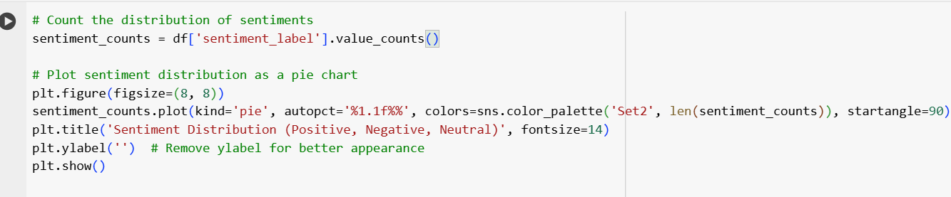

• **Positive Sentiment:** Sentiment score > 0.05

• **Neutral Sentiment:** Sentiment score between -0.05 and 0.05

• **Negative Sentiment:** Sentiment score < -0.05

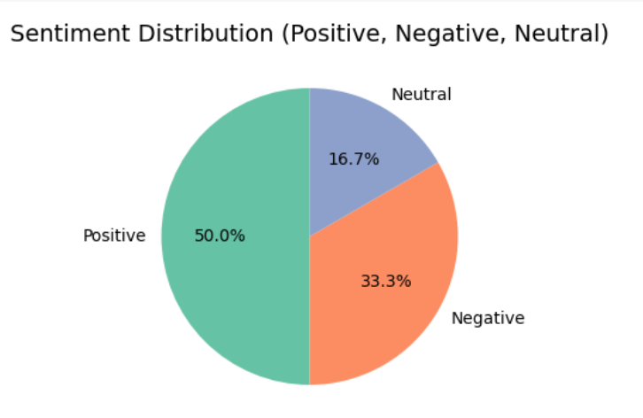

**Sentiment Trends Over Time**

**Time-Based Sentiment Analysis**

To track sentiment trends over time, we group the tweets by their timestamps and calculate the average sentiment score for each time period (e.g.

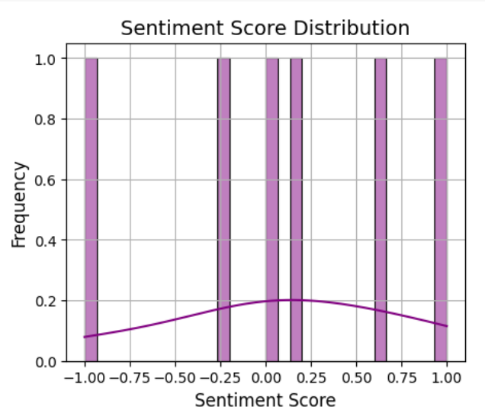

**LIMITATION AND FUTURE WORK**

**Limitations**

* **Data Quality:** The sentiment analysis relies heavily on the quality and accuracy of the tweets collected.
* **Context:** Sarcasm, irony, and cultural context might affect sentiment analysis accuracy.
* **Language:** The analysis is mostly applicable to English tweets, although it can be extended to other languages.

**Future Work**

* Incorporating more advanced NLP models like BERT or GPT-3 for improved sentiment analysis accuracy.
* Analyzing a larger dataset over a longer period to capture more comprehensive sentiment trends.
* Incorporating user demographics (e.g., location, follower count) for more granular insights.

**Conclusion and Insights**

From the sentiment analysis, we can draw several key insights, such as:

* The overall public sentiment (positive, neutral, or negative) toward the specific topic or product.
* Trends or patterns that indicate when public opinion was particularly favorable or unfavorable.
* The effectiveness of marketing campaigns or public relations events based on sentiment shifts.